CMPS 405 Project Phase 1
Section B03

Group Members
Student ID | Student Name
Fahrel Hidayat | 202206836
Josh Erun Bryce Calma | 202203604
Marcus Monteiro | 202206892
Mohd Bashar | 202205153

Task Distribution & Contribution
Student Name | Tasks Assigned | Contribution %
Fahrel Hidayat | VM1 Task 3.2, All VM3 Tasks | 25
Josh Calma | VM1 Task 3.1 and 4 | 25
Marcus Monteiro | VM1 Tasks 1 and 2 | 25
Mohd Bashar | VM1 Task 5, All VM2 Tasks | 25

Screenshots:
VM1
Task 1.1
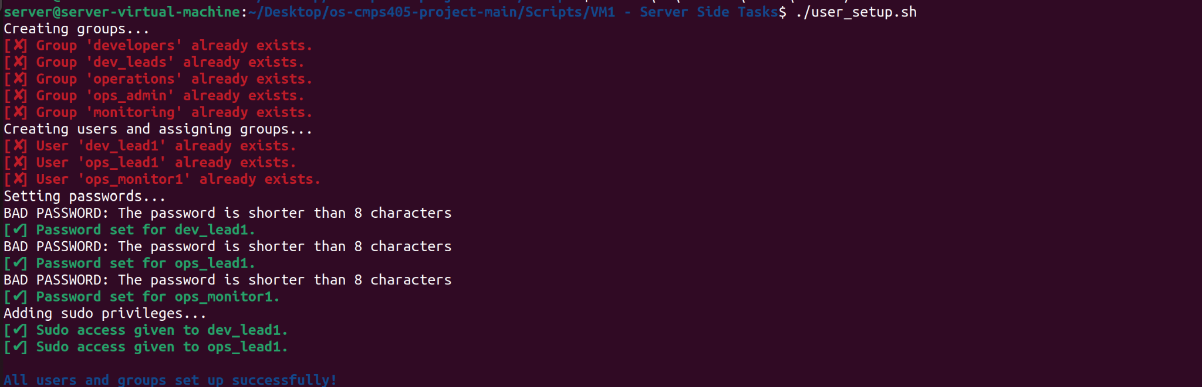
Task 1.2
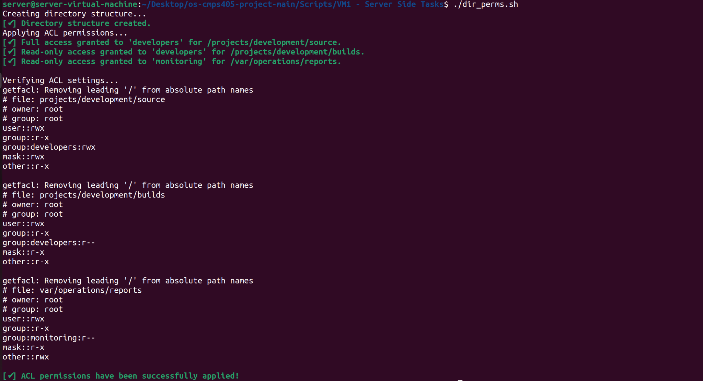

Task 2
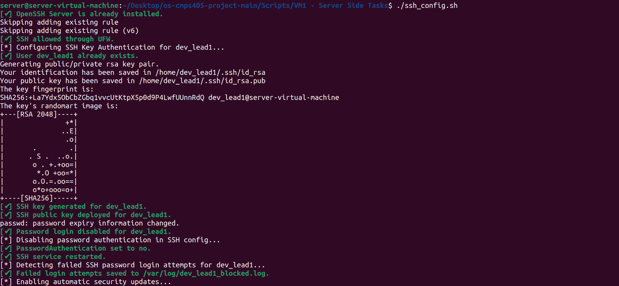
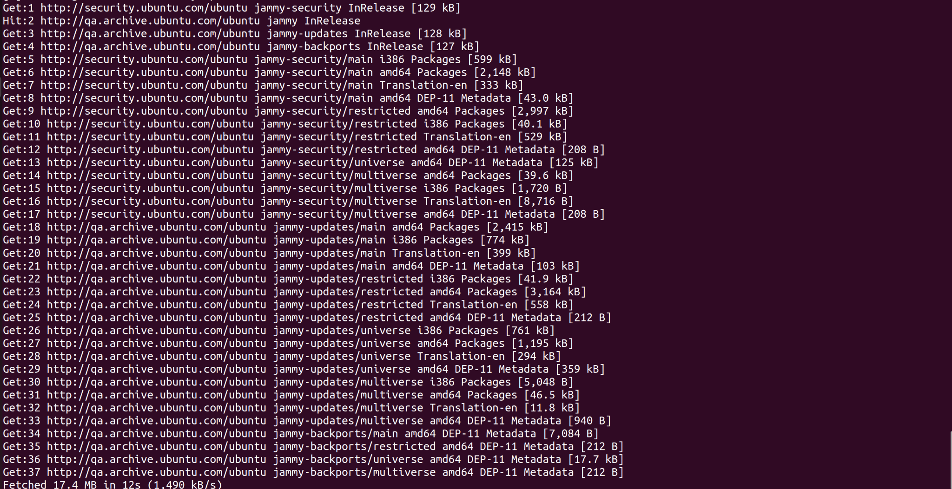
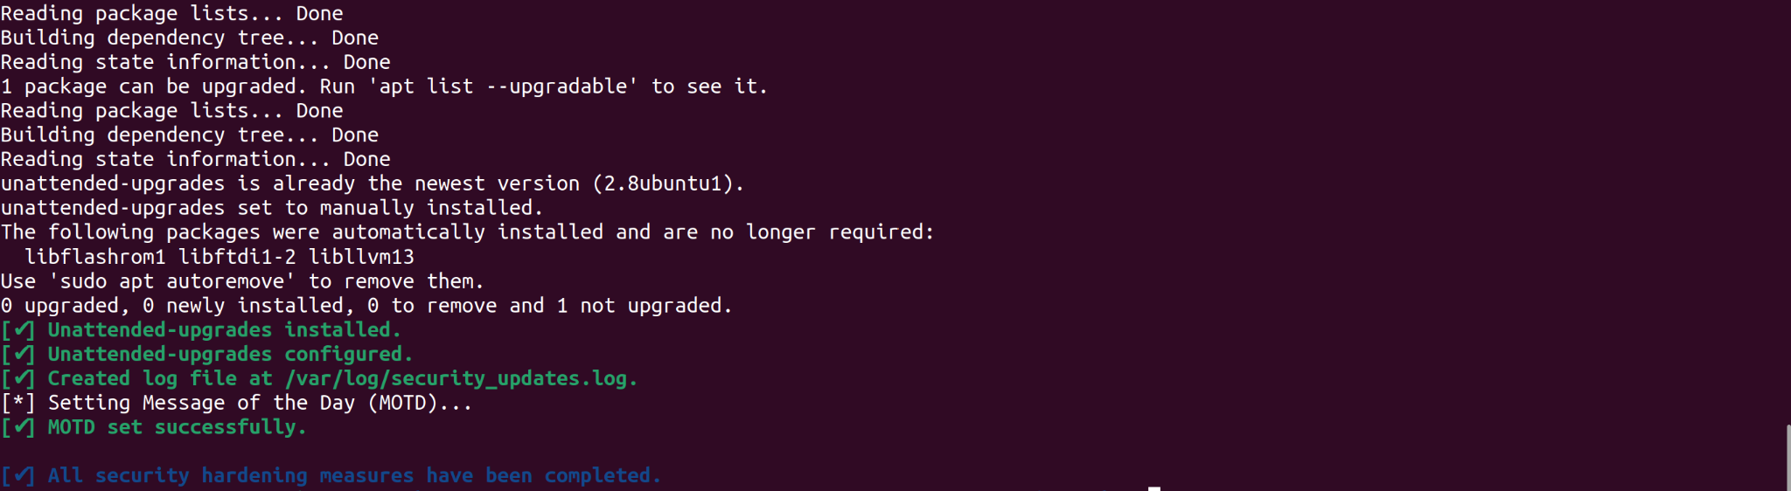
Task 3.1
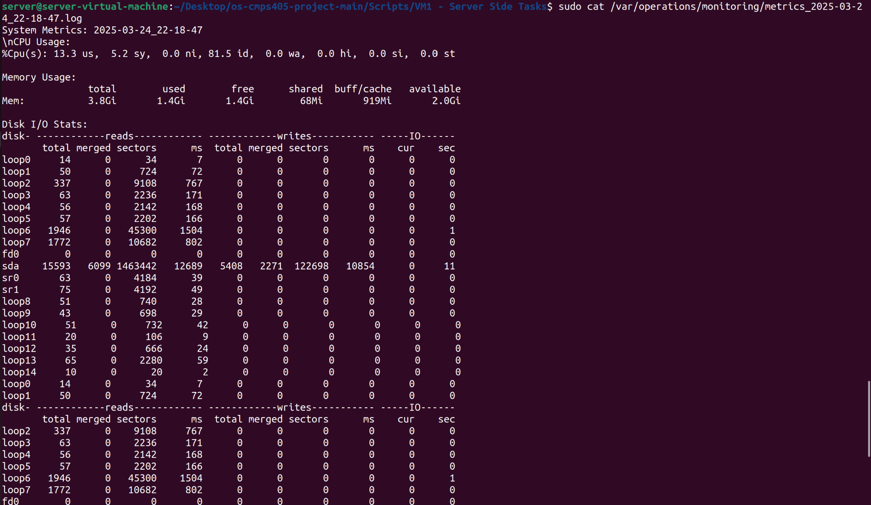
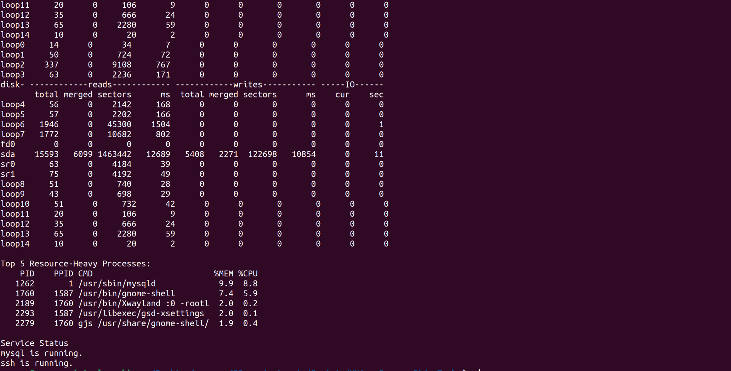
Task 3.2
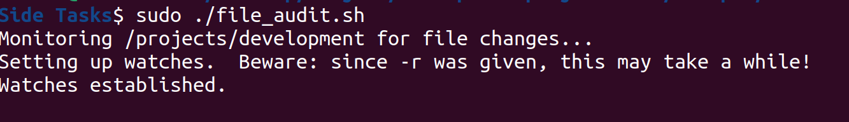
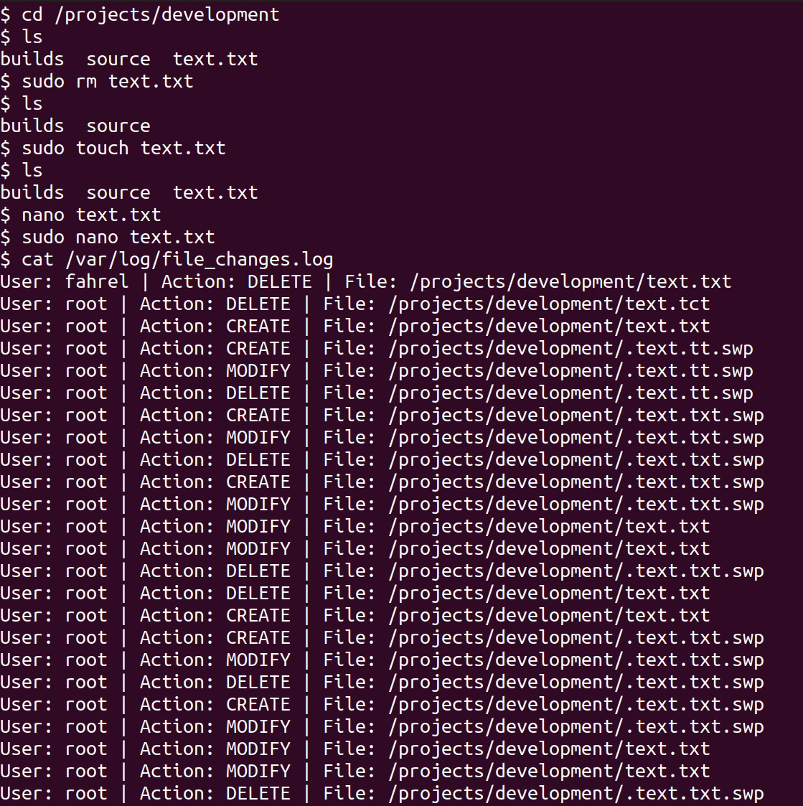

Task 4
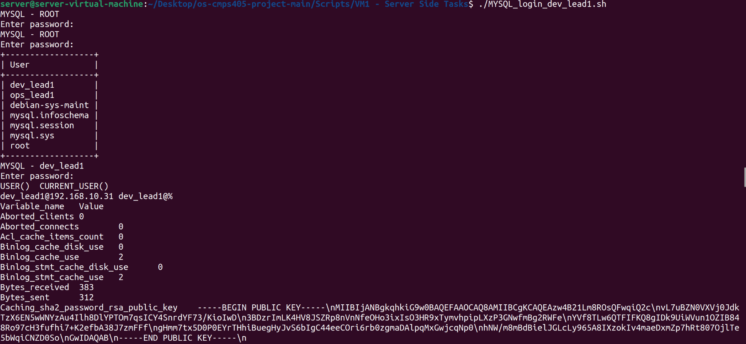
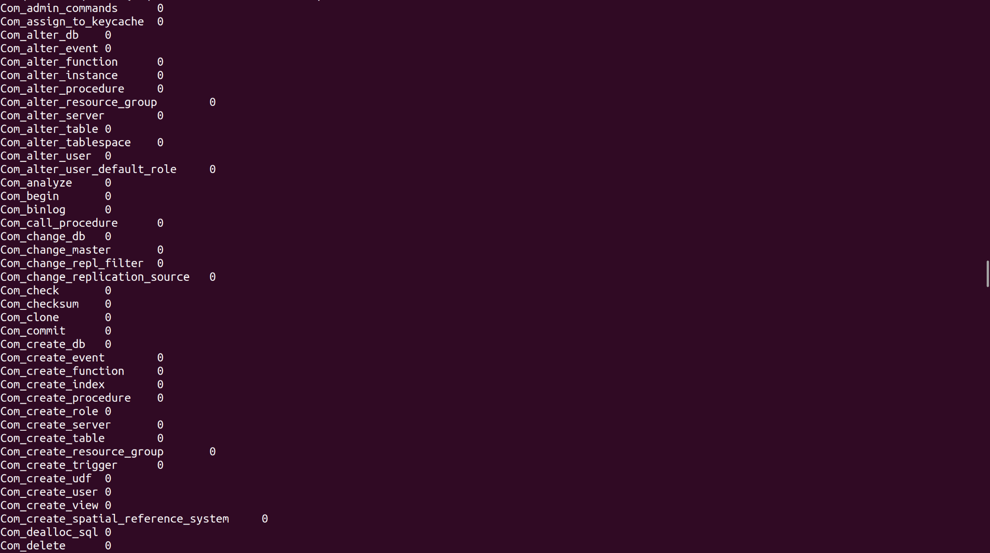
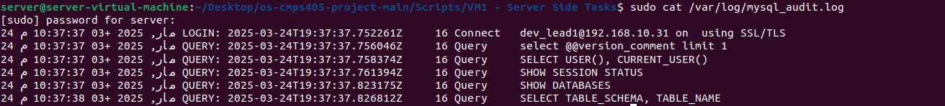

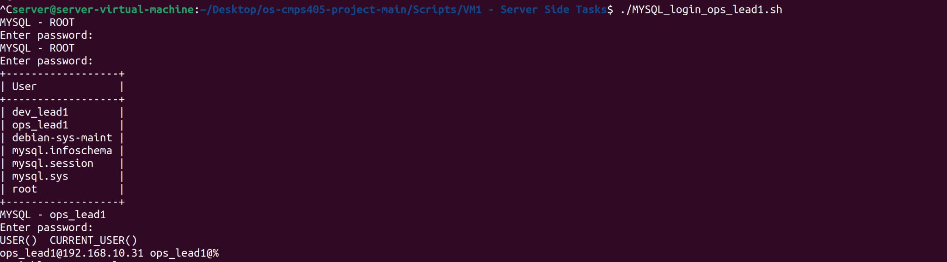
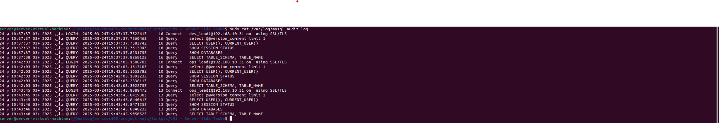

Task 5
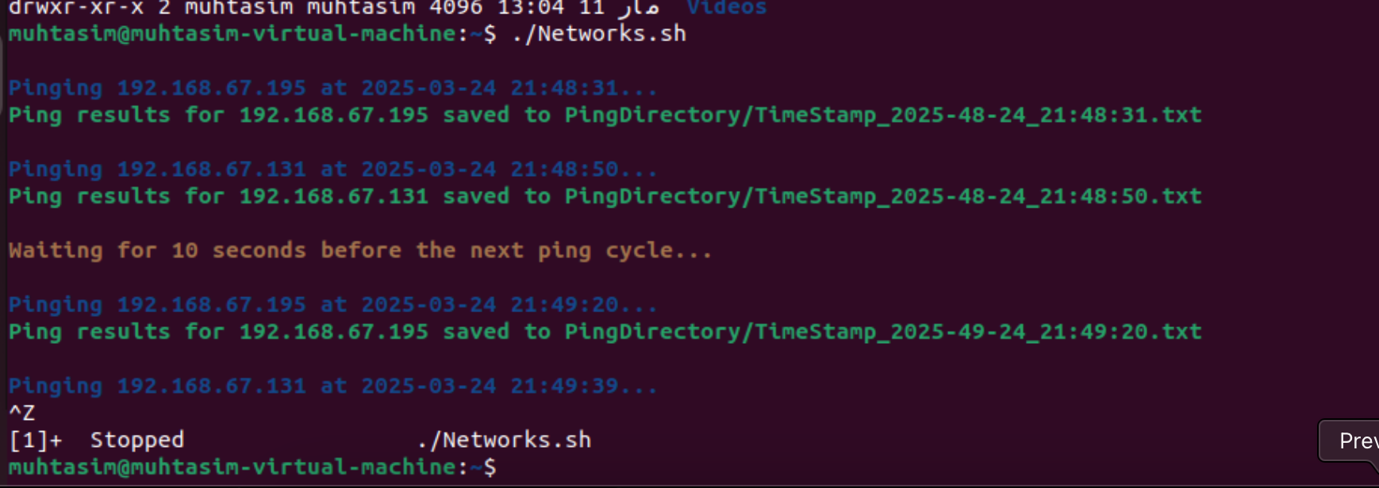
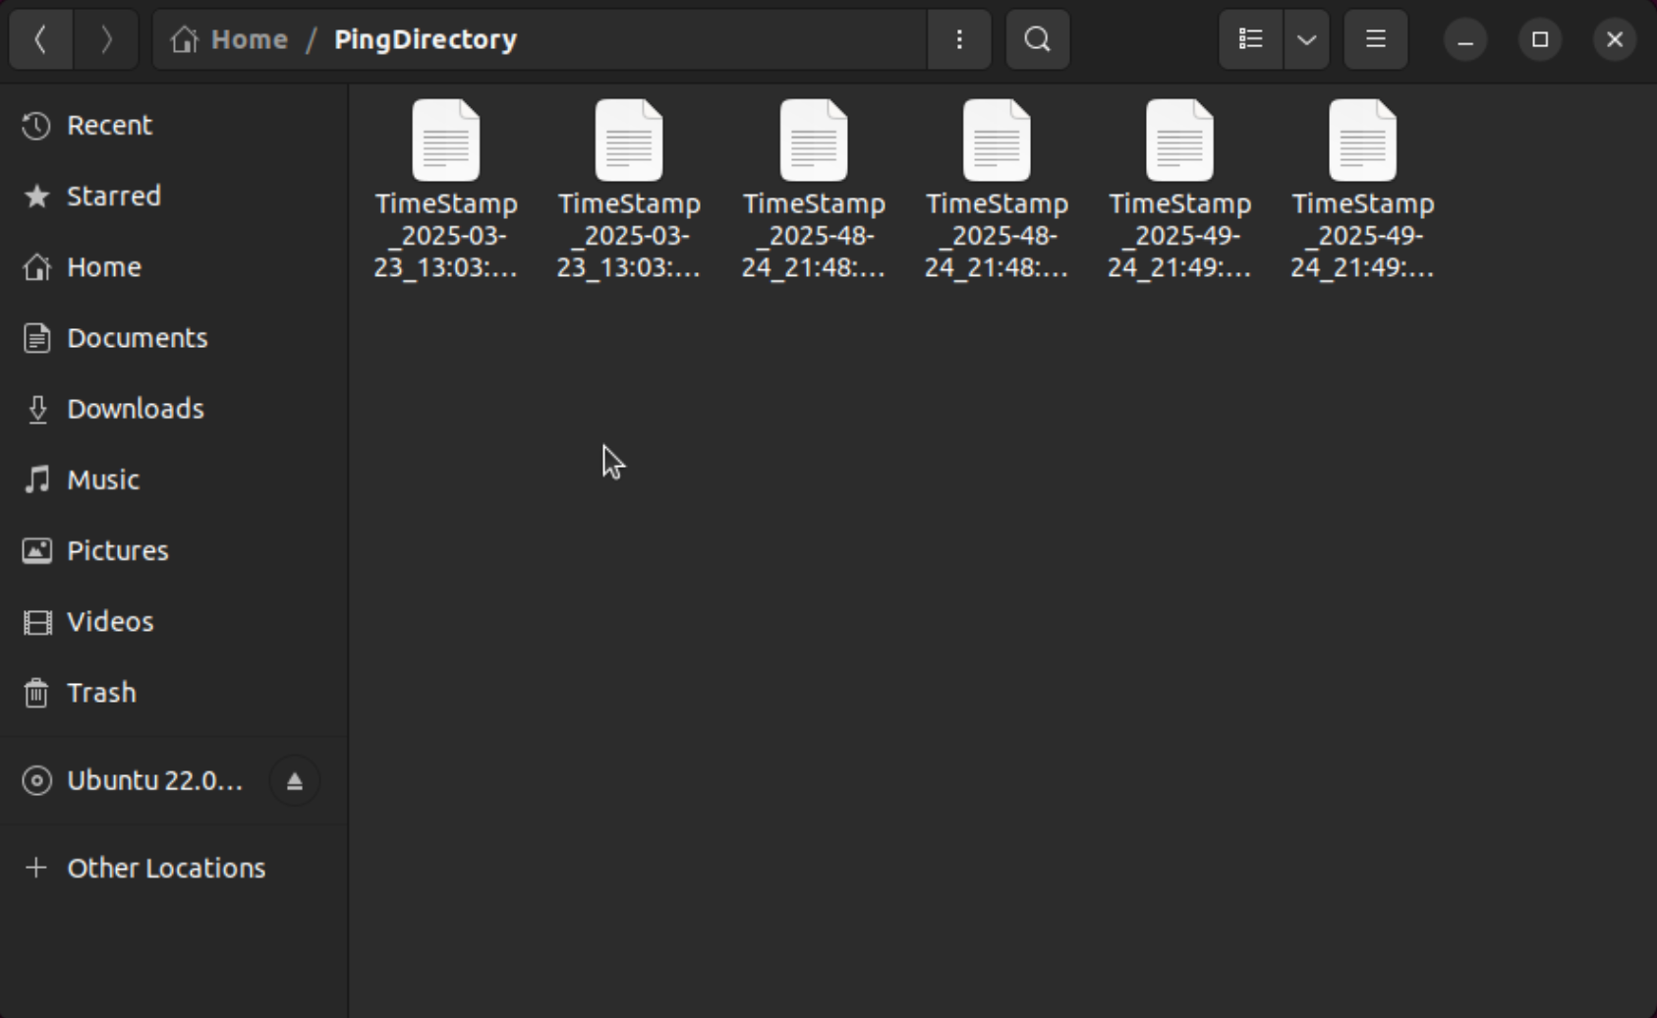

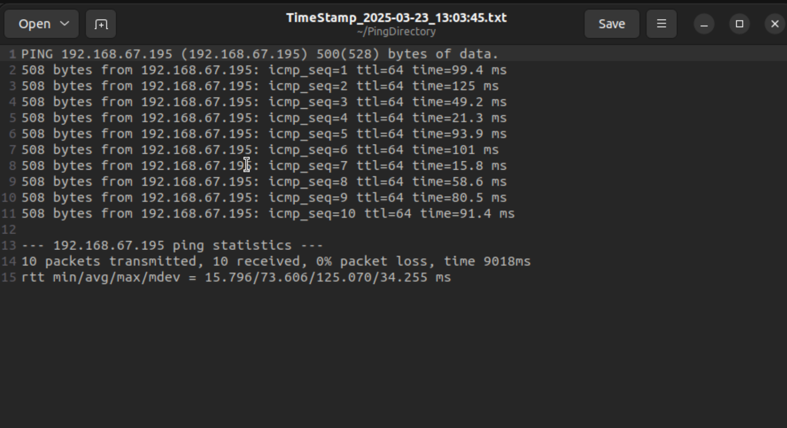

VM2
Task 1.2
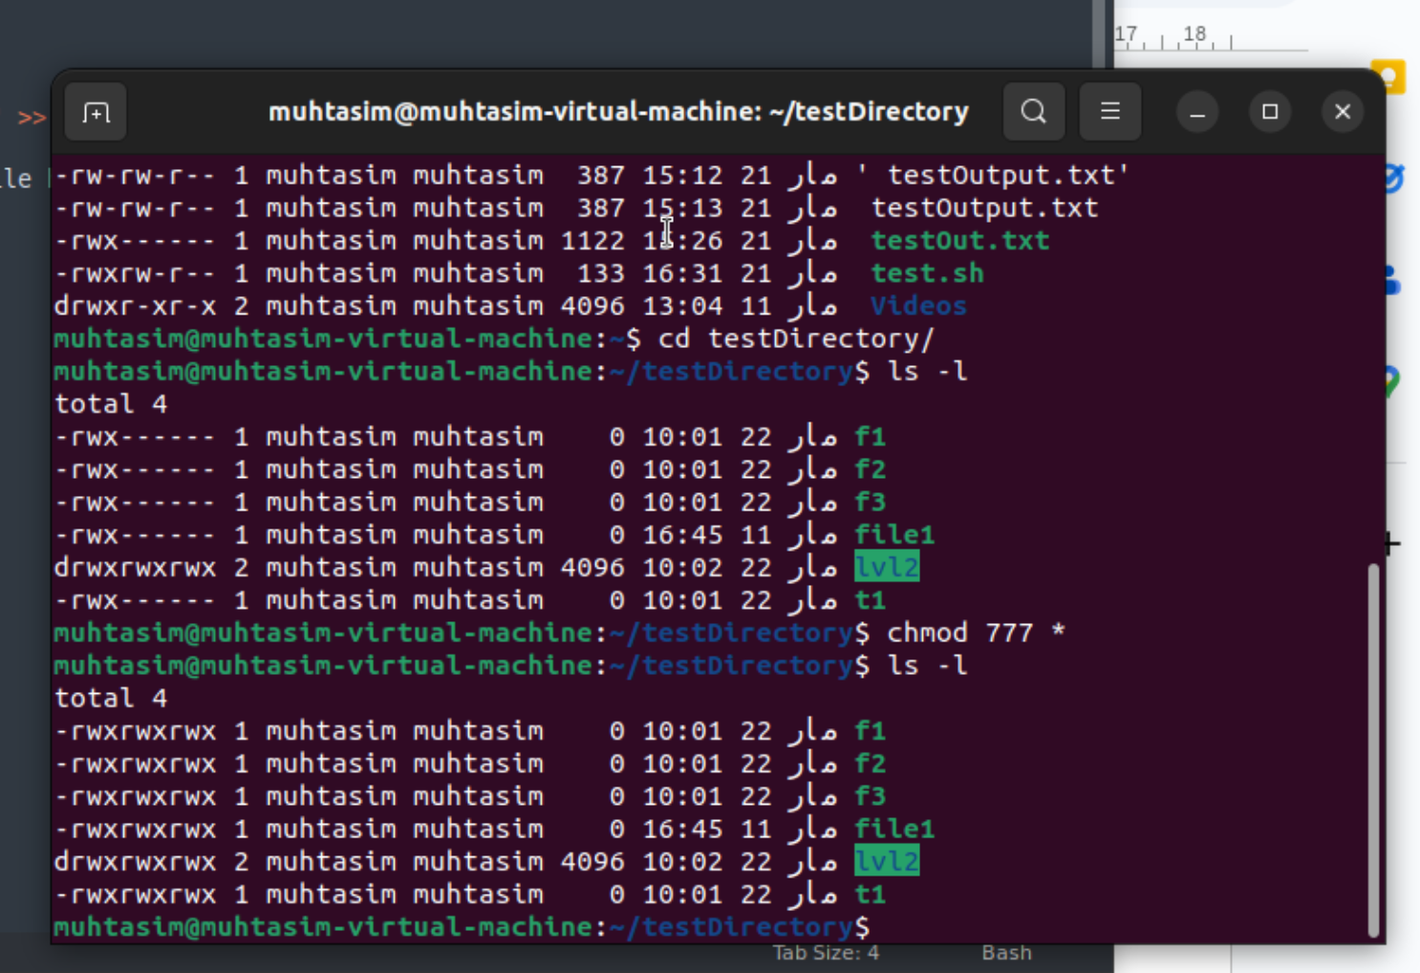

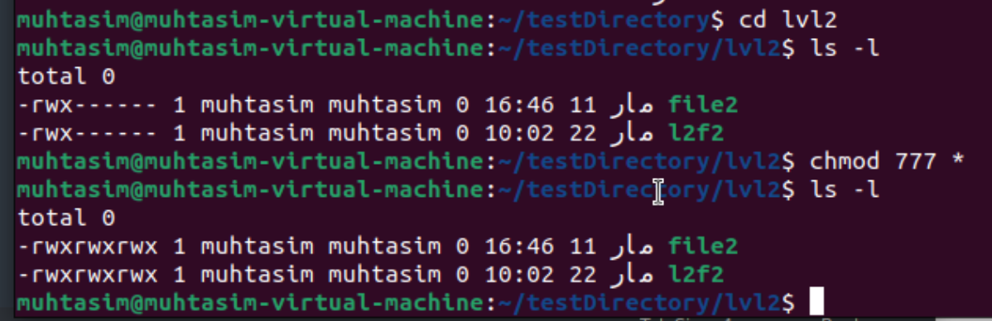
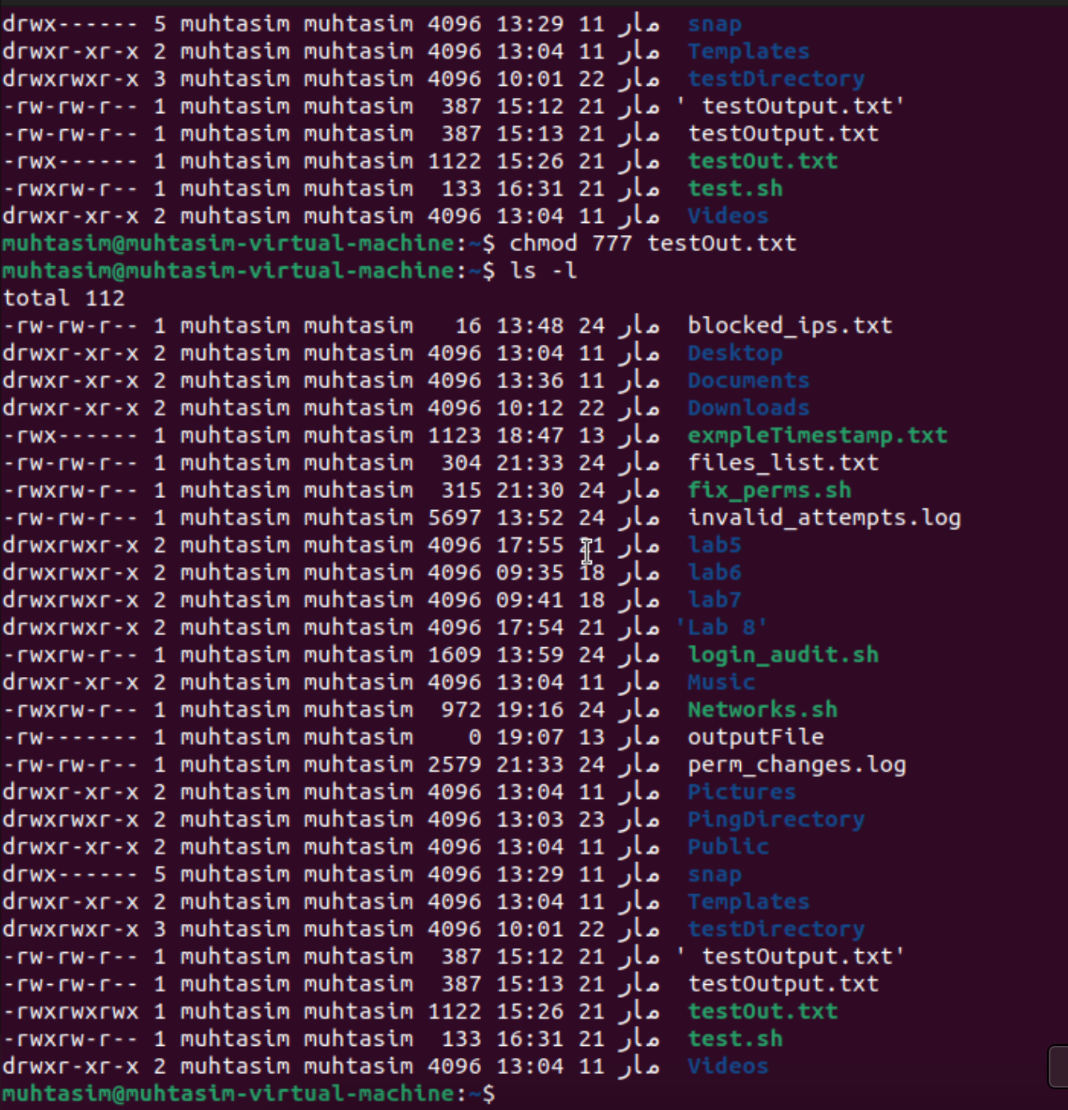

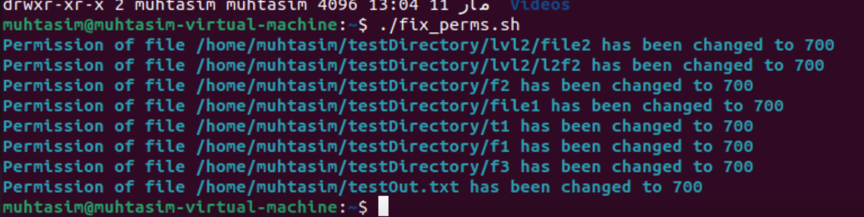
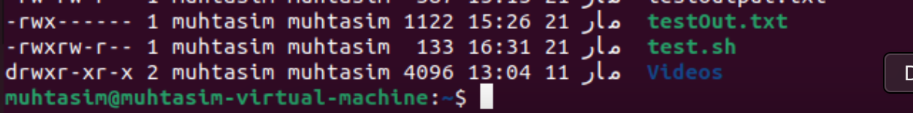

VM3
Task 1
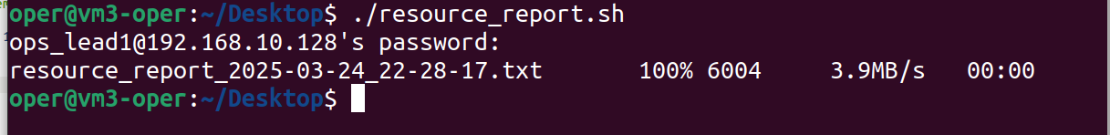
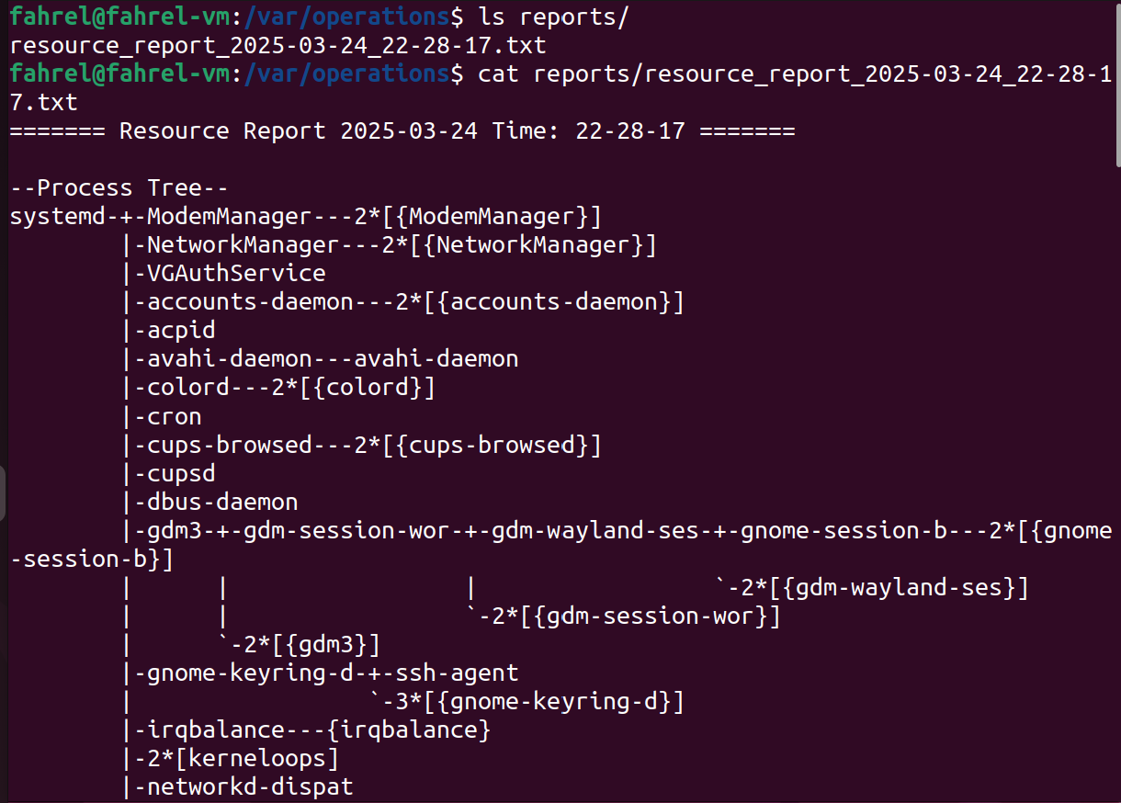
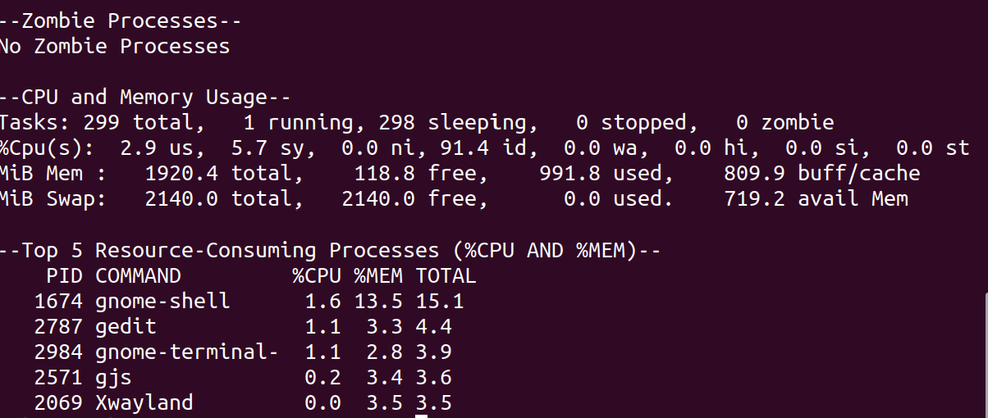
Task 2
